Lab 6: System Configuration
Exercise: Locate the follwing information:
Under the System Summary heading locate and list the following:
Processor: 13th Gen Intel(R) Core(TM) i7-13700, 2100 Mhz, 16 Core(s), 24 Logical Proces…
BIOS Version/Date: Dell Inc. 1.22.0, 17/12/2024

Total Physical Memory: 31.7GB
Under the Hardware Resources heading locate and list the following:
I/O address range for two devices:
Programmable interrupt controller — 0x00000020 – 0x00000021
Communications Port (COM1) — 0x000003F8 – 0x000003FF

IRQ address for two devices:
IRQ 0 System timer
IRQ 4 Communications Port(COM1)
Under the Components heading and Software heading look around to see what
information is provided in these areas.
Locate and provide information about the physical configuration of a disk on the PC.

Item | Value
Description | Disk Drive
Manufacturer | (Standard disk drives)
Model | PM9B1 NVMe Samsung 1024GB
Bytes/Sector | 512
Media Loaded | Yes
Media Type | Fixed hard disk
Partitions | 2
SCSI Bus | 0
SCSI Logical Unit | 0
SCSI Port | 1
SCSI Target ID | 0
SCSI Target Sector | 63
Size | 953.86 GB

Exercise:
1. Use Powershell to retrieve all system and operating system properties from the
computer. Provide the output.
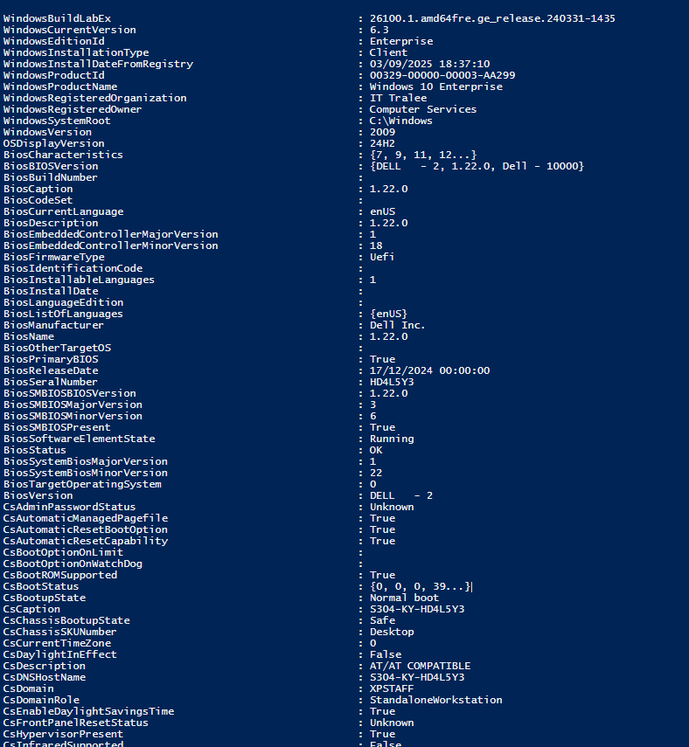
2. Use Powershell to get all computer version properties on your system. Provide
the output.
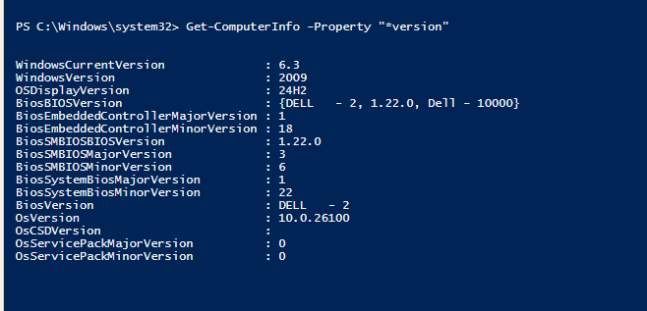
3. Use the -property option with Get-ComputerInfo to return all properties related
to the BIOS.
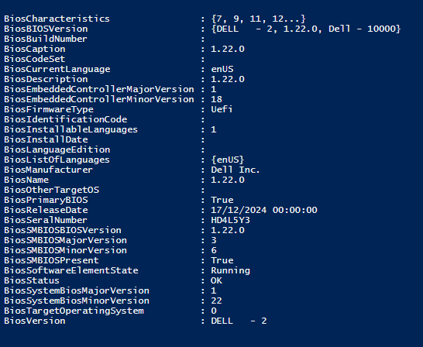

4. Use the Get-ComputerInfo alias to retrieve all HyperV properties.
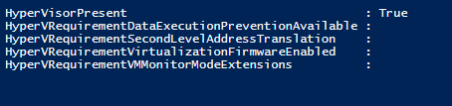
5. Use the Get-Disk cmdlet to retrieve the serial number of an installed disk.


System Configuration
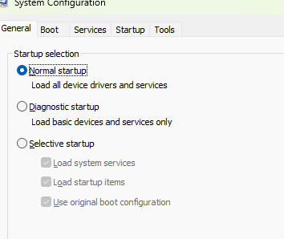
What are the startup options?
Normal Startup
Diagnostic Startup
Selective Startup

Click the Boot tab. This tab is for modifying boot options. Provide a screenshot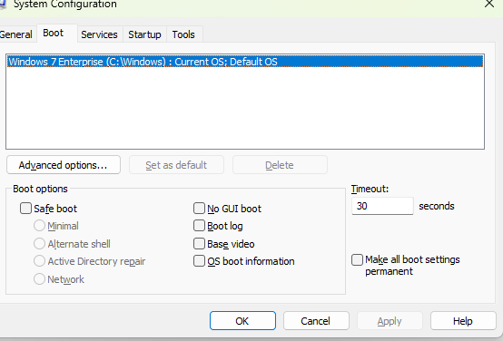
Can you enable and disable services at this tab? Yes
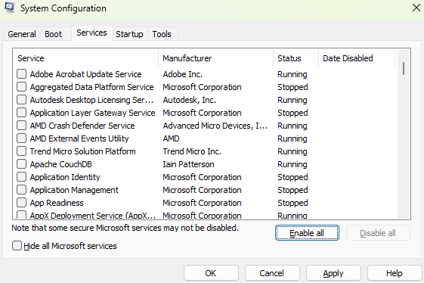
Click the Startup tab. This tab lists the programs that are automatically loaded
every time you turn on your computer.
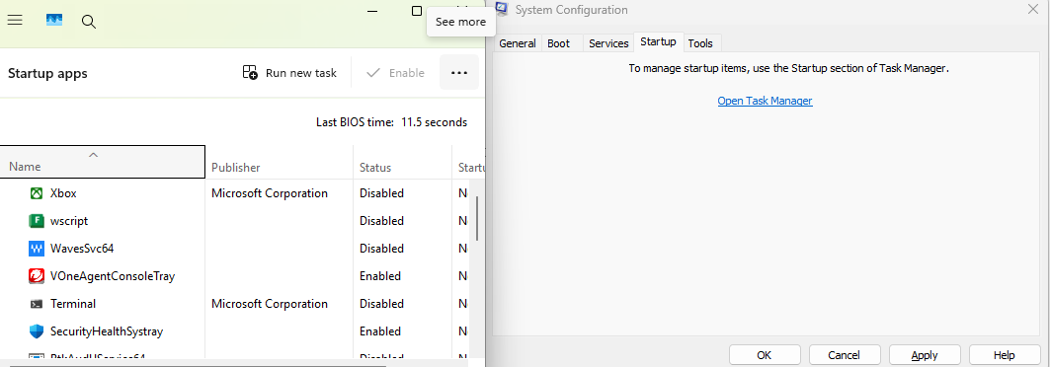

Click the Tools tab. Use this tab to find out how to run System Information using
the command line.
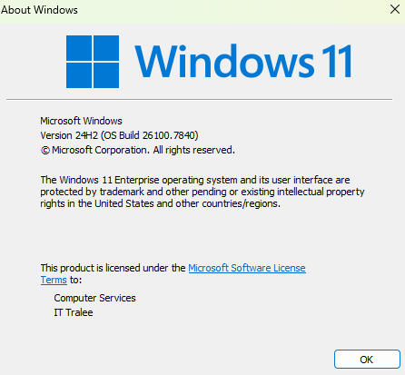
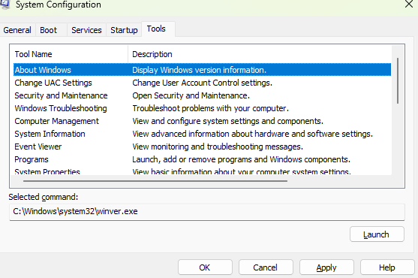
Exercise: Examine what can you do by launching the different applications. Take
Screenshots.
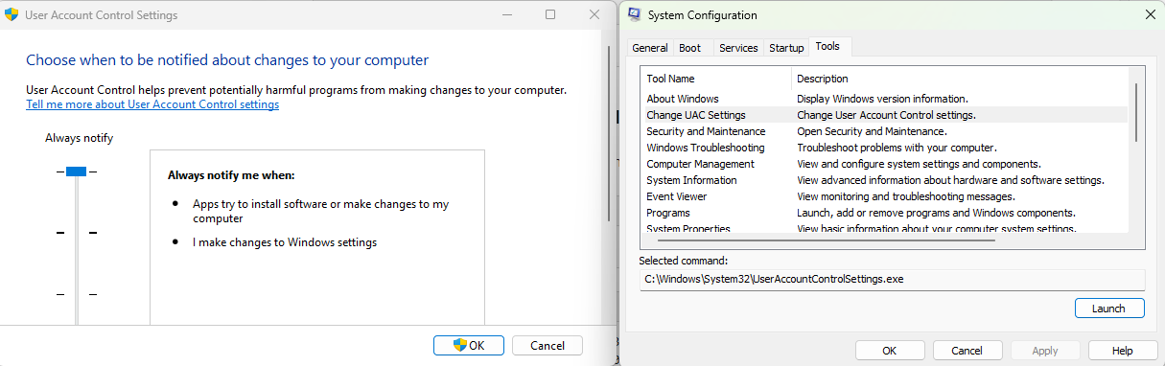
Change UAC Settings
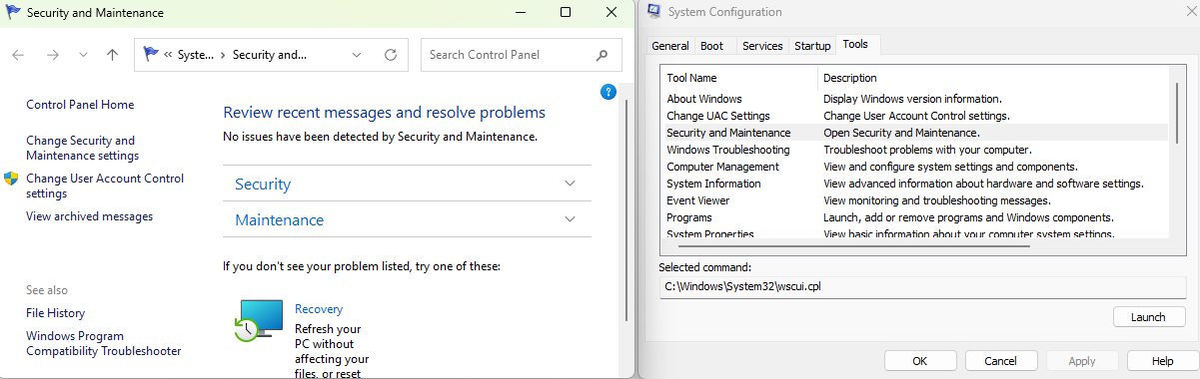
Security and Maintenance
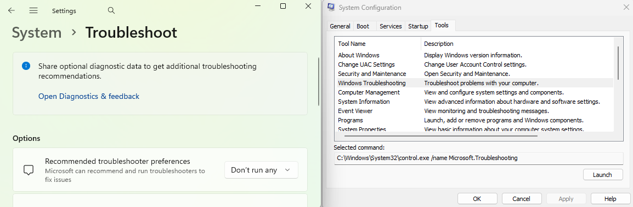
Windows Troubleshooting

Group Policy Editor (gpedit)
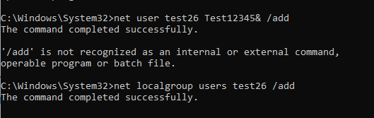
Creating a new user as NOT an administrator. Setting a username and password for a new user as test26 and Test12345&

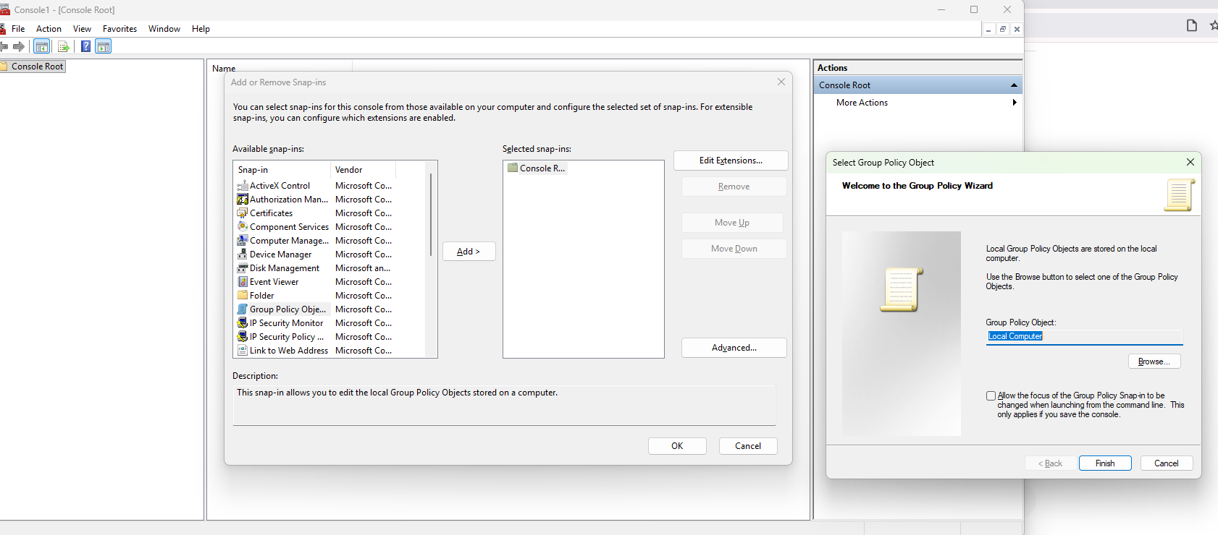
Getting into Local Computer Policy
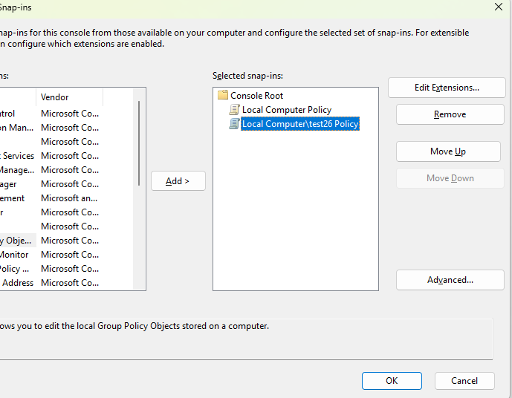
Adding Policy for test-user.
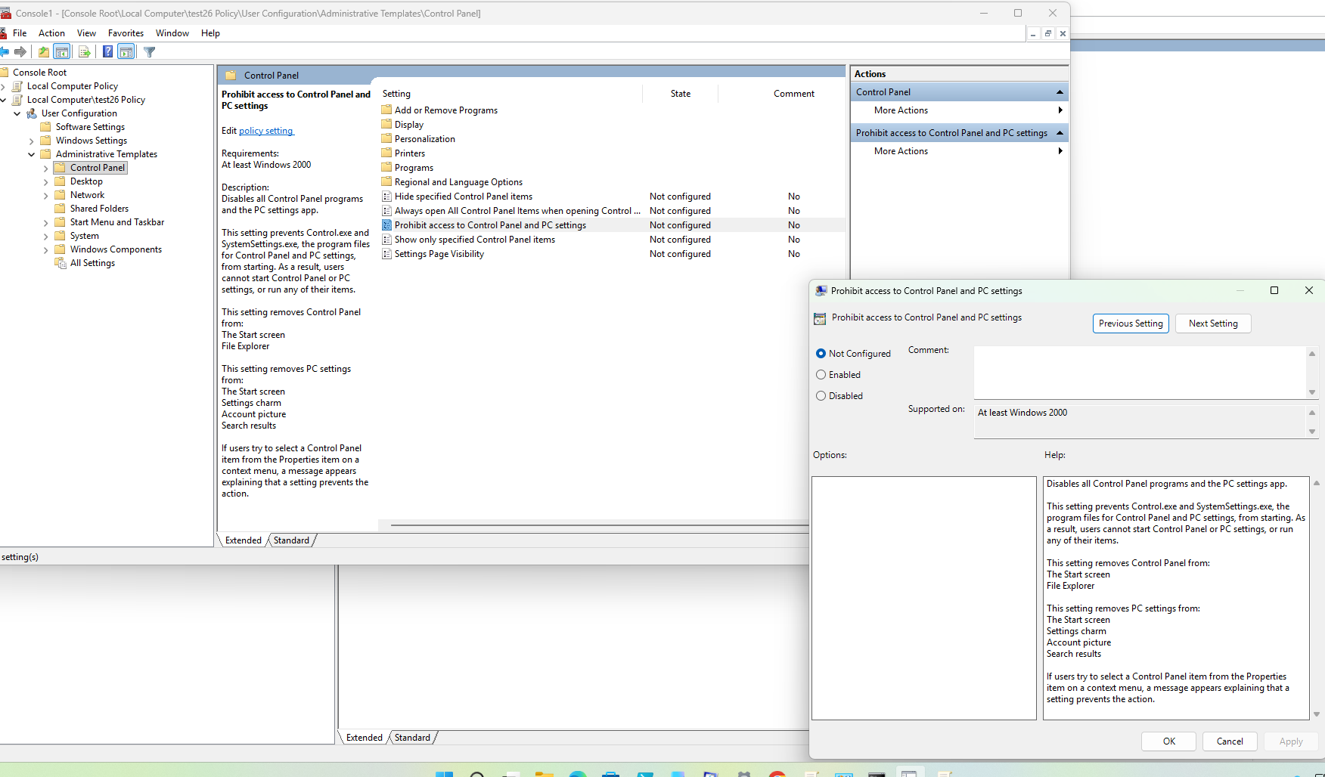
Access for Control Panel is disabled
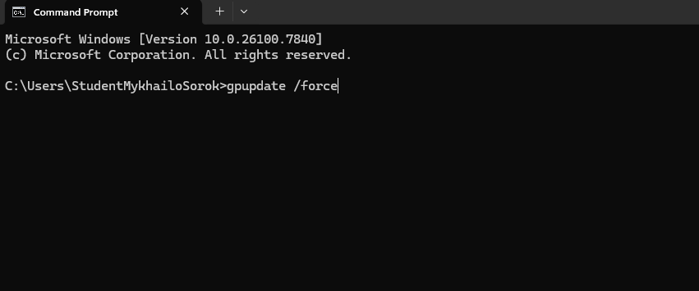
Making forced pgudate.

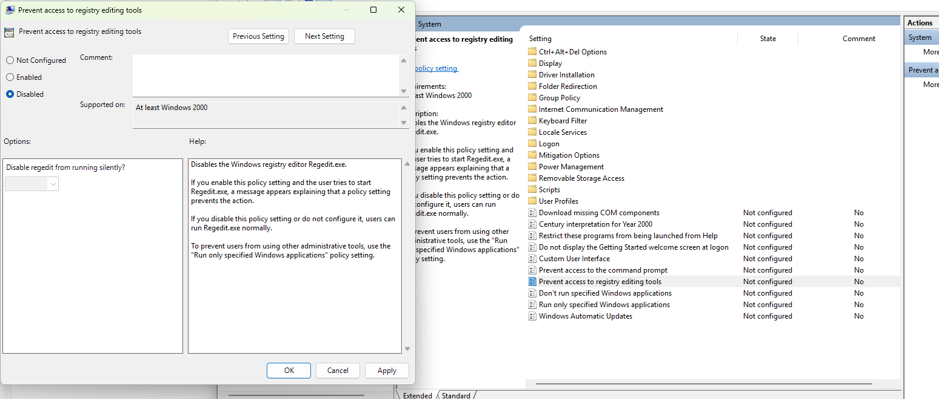
Here I prevented access to registry editing tools disabling it.
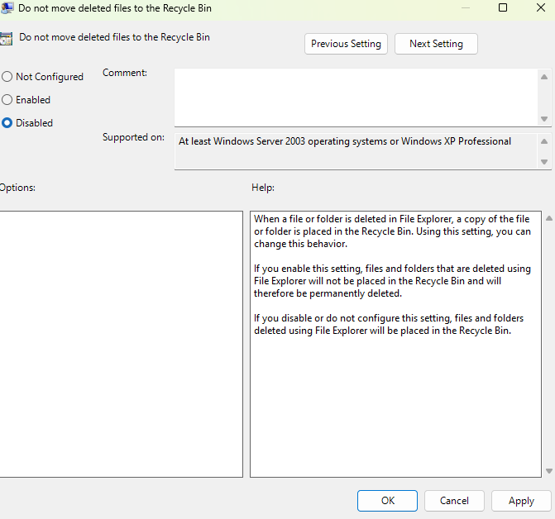
Recycle bin is disable
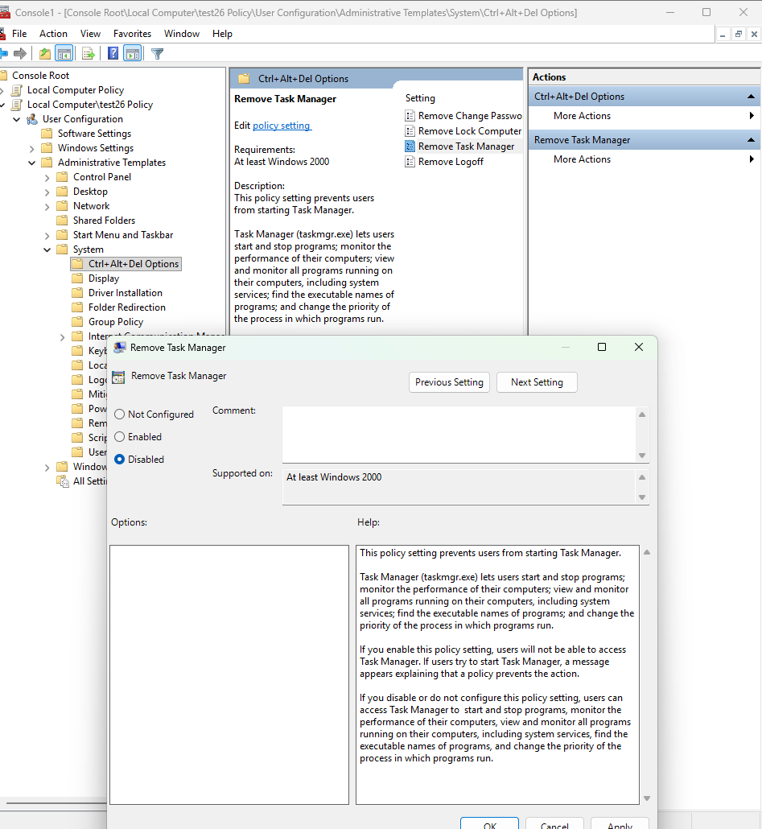 When enabled, Task Manager is removed from the Ctrl+Alt+Del screen.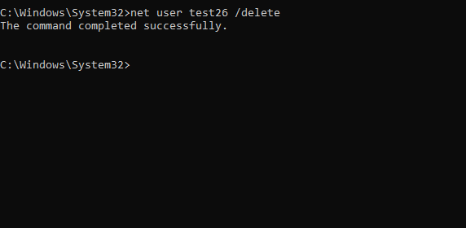
Deleting test user

